library(knitr)

library(tidyverse)

library(wooldridge)

library(stargazer)

library(data.table)

library(car)

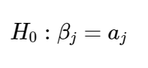

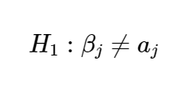

* Obtain t statistics using summary()

data(gpa1, package='wooldridge')

# Store results under "sumres"

sumres <- lm(colGPA ~ hsGPA+ACT+skipped, data=gpa1)

**summary**(sumres)

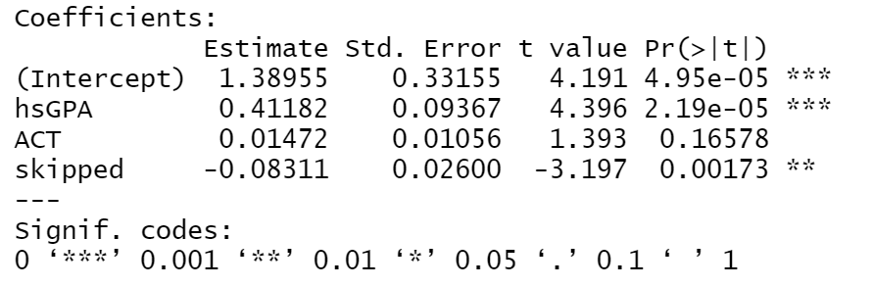

* t-test step by step

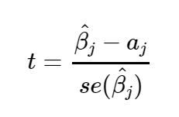

regtable <- summary(sumres)$coefficients

**bhat** <- regtable[2,1]

**se** <- regtable[2,2]

# Reproduce t statistic

tstat <- (bhat - 0) / se

print(paste("t-stat", tstat))

# Reproduce p-value

#First get the absolute value of the tstat

print(paste(" Absolute value of t-stat", abs(tstat)))

# Use the ***pt() probability*** of the t-distribution with 137 degrees of freedom

print(paste("Prob of tstat", pt(-abs(tstat),137)))

# Because this a two tails test you multiply it by two and let's round it so it looks better

print(paste("p-value", round((pval<-2*pt(-abs(tstat),137)), 5)))

* Using Stargazer

stargazer(lm(colGPA ~ hsGPA+ACT+skipped, data=gpa1), type="text")

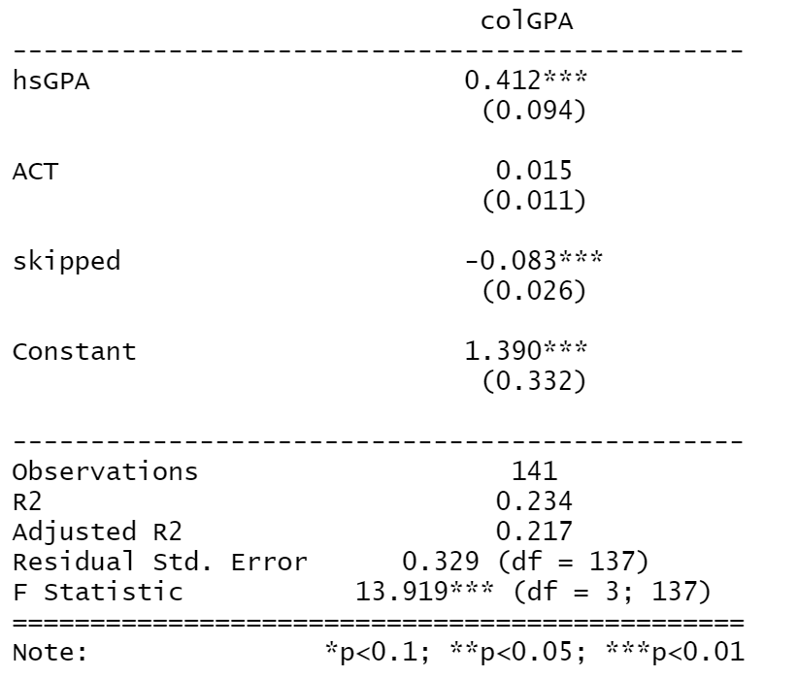

* Check **confidence intervals** for all parameters in the regression at 99%

**confint**(sumres, level=0.99)

* **F test using linearHypothesis()**

res.ur <- lm(log(salary) ~ years+gamesyr+bavg+hrunsyr+rbisyr, data=mlb1)

***# vector with the names of the variables that you are testing: the null is that parameters for these 3 are all 0***

**myH0 <- c("bavg","hrunsyr","rbisyr")**

**linearHypothesis(res.ur,myH0)**

* **F test using anova function**

**anova(res.r,res.ur)**

* **Testing of other hypothesis**

*#We can perform a more complicated hypothesis like that there is a relation between two variables Bi =c $∙$ Bi where c is a constant. (i.e.,*

*Hypothesis:*

*bavg = 0*

*hrunsyr - 2 rbisyr = 0*

*)*

myH0 <- c("bavg", "hrunsyr=2*rbisyr")

linearHypothesis(res.ur,myH0)

* **F test step-by-step**

# CV for alpha=1% using the F distribution with 3 and (n-k-1=353-5-1) 347 degrees of freedom d.f. :

print(paste("Critical value at 1% with 3 and 347 df=",qf(1-0.01, 3,347)))

# Use mlb1 data about salaries of baseball players

data(mlb1, package='wooldridge')

# Unrestricted OLS regression:

res.ur <- lm(log(salary) ~ years+gamesyr+bavg+hrunsyr+rbisyr, data=mlb1)

# Restricted OLS regression:

res.r <- lm(log(salary) ~ years+gamesyr, data=mlb1)

# R2

r2.ur <- summary(res.ur)$r.squared # R squared unrestricted

r2.r <- summary(res.r)$r.squared # R squared restricted

print(paste("$R^2$ unrestricted=", r2.ur))

print(paste("$R^2$ restricted=", r2.r))

print(paste("Model degrees of freedom=", res.ur$df))

# F statistic:

F <- (r2.ur-r2.r) / (1-r2.ur) * res.ur$df/3

print(paste("F-stat=", F))

# p value = 1-cdf of the appropriate F distribution: 3 restrictions

print(paste("p-value=", round(1-pf(F, 3, res.ur$df),9)))